**Global tool configuration:**

* We need to configure about our tools in here
* We need to give the name and path. Example, if we don’t give the location here. When we use java commands in job, the Jenkins can’t know where the java is

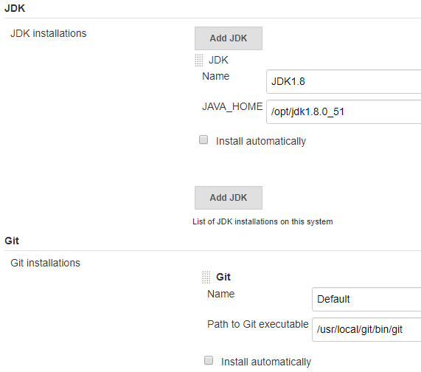

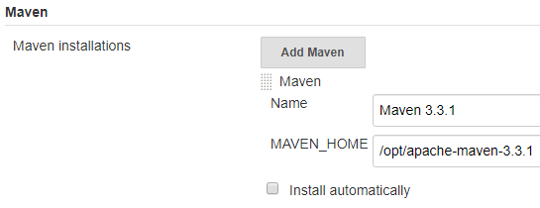

* If we select install automatically, Jenkins will automatically install it when it starts, it is better to download manually and give the path
* Jenkins application level configuration done in system configuration and global tool configuration settings

**Configure global security:**

* Here we can do security related tasks. We can enable the security as below and restrict the users as per “role based” or “project based” or “matrix based” security strategies

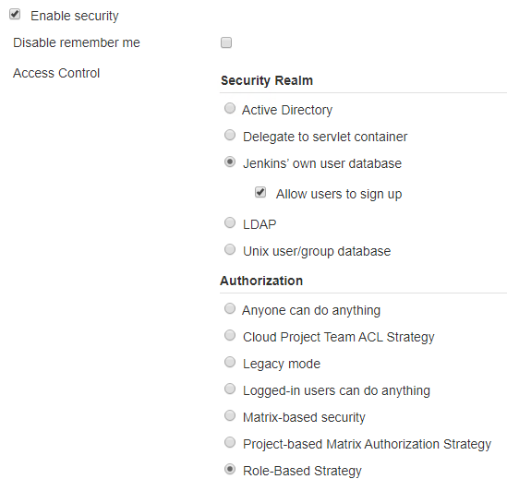

* We can use matrix based as below

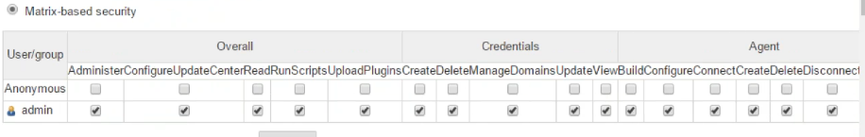

* We can create a user under manage user settings and then we can give him the access whatever we want under matrix-based security